Prog6212 Part 1
Uriel James Etanda
ST10491676

ERD Creation

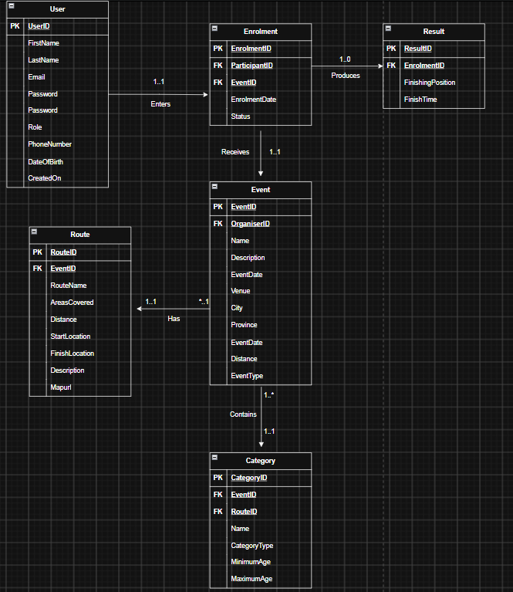

Endpoint Creation

HTTP Method | Route | Description | Role | Request Body | Expected Response
POST  (Registration endpoint) | /api/auth/register | Registers a new RaceDay user as an organiser or as a participant. | Public | FirstName, LastName, Email, Password, Role, PhoneNumber, DOB. | 201 Created- account successfully registered.  400 Bad request- invalid/missing data.  409 Conflict- email already exists.
POST  (Login Endpoint) | /api/auth/login | Allows the user to login once the account has been created | Public | Email, Password | 200 Ok- successful login + authentication session created  400 Bad Request- Missing/Invalid data  401 Unauthorised- Invalid email/password
GET  (Viewing Endpoint) | /api/users/me | Retrieves the authenticated user’s profile information | Authenticated User | None | 200 Ok-returns the user’s profile.  401 Unauthorised- user not authenticated.  404 Not found- user profile cannot be found.
PUT  (Endpoint to Update profile) | /api/users/me | Updates the authenticated user’s profile information. | Authenticated user | FirstName, LastName, PhoneNumber,  DateOfBirth | 200 OK – profile updated successfully. 400 Bad Request – invalid data. 401 Unauthorized – user is not authenticated. 404 Not Found – user profile cannot be found.
GET  (View Events Endpoint) | /api/events | Retrieves the list of available events | Authenticated user | None | 200 OK – returns a list of events. 401 Unauthorized – user is not authenticated.
POST  (Create Event Endpoint) | /api/events | Creates a new event managed by the authenticated organiser | Organiser | Name, Description, EventDate, Description, Venue, City, Province, DinstanceKM, EventType | 201 Created – event created successfully. 400 Bad Request – invalid event data. 401 Unauthorized – user is not authenticated. 403 Forbidden – user is not an Organiser.
PUT  (Update Event Endpoint) | /api/events/{id} | Updates an existing event that is managed by the authenticated organiser. | Organiser | Name, Description, EventDate, Venue, City, Province, DistanceKm, EventType | 200– event updated successfully. 400 Bad Request – invalid event data. 401 Unauthorized – user is not authenticated. 403 Forbidden – user is not an Organiser or does not manage the event. 404 Not Found – event does not exist.
DELETE  (Delete Event Endpoint) | /api/events/{id} | Deletes an existing event that is managed by the authenticated organiser. | Organiser | None | 204 No Content – event deleted successfully. 401 Unauthorized – user is not authenticated. 403 Forbidden – user is not an Organiser or does not manage the event. 404 Not Found – event does not exist.
GET  (View a specific event endpoint) | /api/events/{id} | Retrieves the details of a specific event. | Authenticated user | None | 200 OK – returns the event details. 401 Unauthorized – user is not authenticated. 404 Not Found – event does not exist.
POST  (create category endpoint) | /api/events/  {eventide}/categories | Creates an age or distance category for a specific event. | Organiser | Name, CategoryType, MinimumAge, MaximumAge, RouteId | 201 Created – category created successfully. 400 Bad Request – invalid category data. 401 Unauthorized – user is not authenticated. 403 Forbidden – user is not an Organiser or does not manage the event. 404 Not Found – event or route does not exist.
GET  (View Event Categories Endpoint) | /api/events/{eventID}/  categories | Retrieves all categories available for a specific event. | Authenticated User | None | 200 OK – returns the event's categories. 401 Unauthorized – user is not authenticated. 404 Not Found – event does not exist.
POST  (Enrol In An Event Endpoint) | /api/events/{eventID}/  enrolments | Enrols the authenticated Participant in an event by selecting a category. | Participant | CategoryID | 201 Created – enrolment created successfully. 400 Bad Request – invalid category or enrolment data. 401 Unauthorized – user is not authenticated. 403 Forbidden – user is not a Participant. 404 Not Found – event or category does not exist. 409 Conflict – participant is already enrolled in the selected event/category.
GET  (View one’s own enrolments endpoints) | /api/users/me/  enrolments | Retrieves the authenticated participant’s event enrolments. | Participant | None | 200 OK – returns the Participant's enrolments. 401 Unauthorized – user is not authenticated. 403 Forbidden – user is not a Participant.
GET  (Organiser viewing od the event enrolments endpoint) | /api/events/{eventID}  /enrolments | Retrieves all Participant enrolments for an event managed by the authenticated Organiser. | Organiser | None | 200 OK – returns the event's enrolments. 401 Unauthorized – user is not authenticated. 403 Forbidden – user is not an Organiser or does not manage the event. 404 Not Found – event does not exist.
POST  (Record a result endpoint) | /api/enrolment/  {enrolmentID}/result | Records the finishing position and finish time for a Participant's enrolment. | Organiser | FinishingPosition, FinishTIme | 201 Created – result recorded successfully. 400 Bad Request – invalid result data. 401 Unauthorized – user is not authenticated. 403 Forbidden – user is not an Organiser or does not manage the event. 404 Not Found – enrolment does not exist. 409 Conflict – a result already exists for this enrolment.
GET  (View own results endpoint) | /api/users/me/results | Retrieves the authenticated Participant's results from completed event enrolments. | Participant | None | 200 OK – returns the Participant's results. 401 Unauthorized – user is not authenticated. 403 Forbidden – user is not a Participant.
POST  (Create route endpoint) | /api/events/{eventID}  /routes | Create a route for an event owned by the organiser | Organiser | RouteName, AreasCovered, DistanceKm, StartLocation, FinishLocation, Description, MapUrl | 201 Created, 400 Bad Request, 401 Unauthorized, 403 Forbidden, 404 Not Found
PUT  (Create route endpoint) | /api/events/{eventId}/  Routes/{routeId} | Updates a route belonging to an event owned by the authenticated organiser. | Organiser | RouteName, AreasCovered, DistanceKm, StartLocation, FinishLocation, Description, MapUrl | 200 OK, 400 Bad Request, 401 Unauthorized, 403 Forbidden, 404 Not Found

- After the endpoint creation, I proceeded to create the tables inside my sql workspace.
- Instead of inserting my sql code here, I committed the query to Github.

